**High Performance Computing**

**System Administrator**



CENTRE FOR DEVELOPMENT OF ADVANCED COMPUTING PUNE

**CASE STUDY**

**Submitted By:**

**Batch March 15-aug 31**

**AIM**

Build a two node Disk-less HPC-Cluster using OpenHPC with Xcat, Slurm, Nagios.

Group Members:

| S No. | NAME | PRN |
| --- | --- | --- |
| 01 | Shubham Nimkar | 230340127009 |
| 02 | Subhashit subhash sathe | 230340127011 |
| 03 | Vikas Rai | 230340127013 |
| 04 | Khedekar Manjiri Mangesh | 230340127039 |

**Case Study**

XCAT, SLURM, NAGIOS, LDAP

We are building the Cluster using the above technologies. Initially we will build one machine that will be work as a Master for our cluster.

* Hardware Configuration for Master :

Processor : 2 CPU, each includes 2 cores (2x2) 4 virtual cores

RAM : 8 GB

HDD : 50 GB

N/W Adapter : NAT

OS : Centos 7

Once the basic setup for master is done we need to configure some basic prerequisites for cluster building.

first disable the firewall service

*# systemctl stop firewalld*

*# systemctl disable firewalld*

Disable the secured linux mode as SELINUX=disable by editing the file /etc/selinux/config

*# vim /etc/selinux/config*

goto line no 7 make SELINUX=disabled

save the file by pressing esc:wq!

*# hostanamectl set-hostname master*

*# exec bash*

Make entry to the /etc/hosts

192.168.20.198 master master.cdac.in (ip_address hostname hostname.domain)

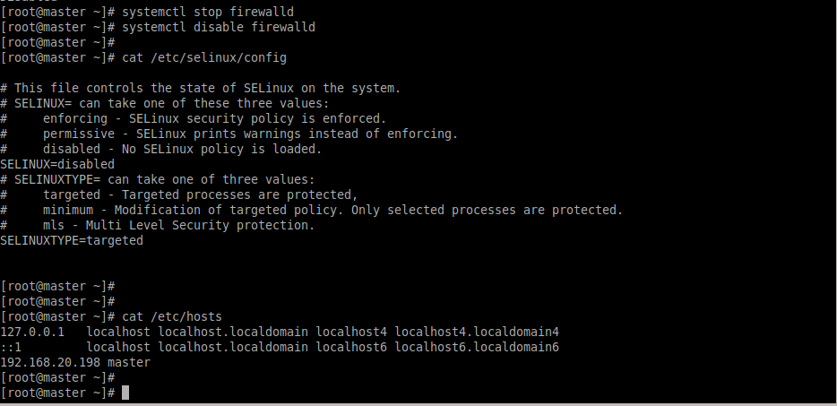

Make the access to node1 and node2 as password less using “password less ssh” using the ssh-keygen method

*# ssh-keygen*

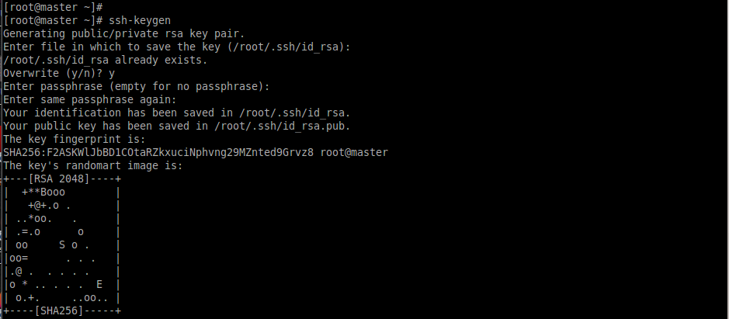

*# ssh-copy-id* [*root@192.168.20.200*](mailto:root@192.168.20.200)

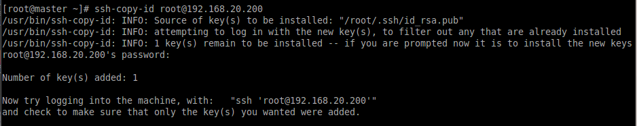

*# ssh-copy-id* [*root@192.168.20.201*](mailto:root@192.168.20.201)

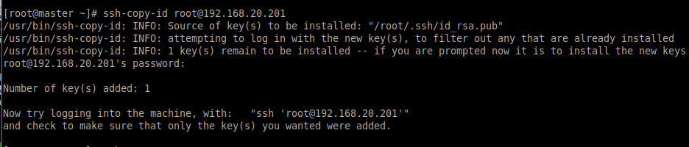

* **XCAT installation**

*# yum install yum-utils -y*

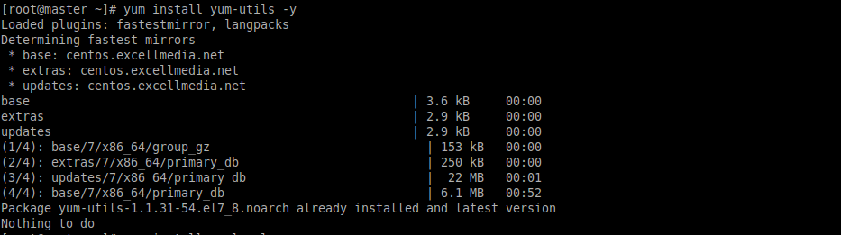

*# yum install epel-release -y*

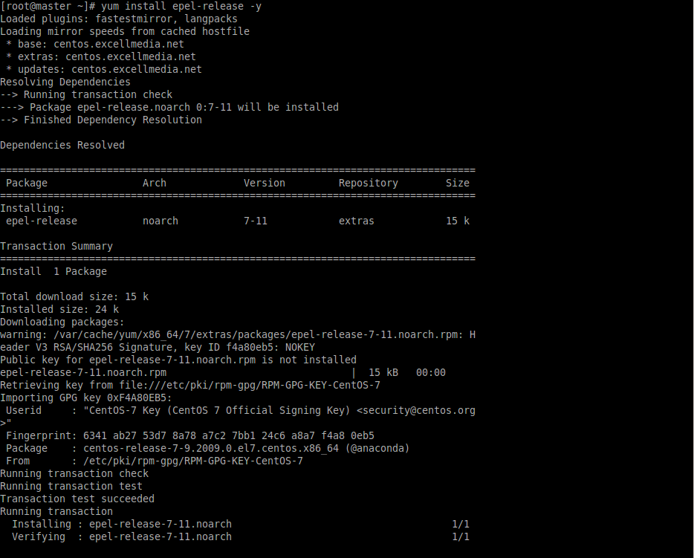

*# wget -P /etc/yum.repos.d https://xcat.org/files/xcat/repos/yum/latest/xcat-core/xcat-core.repo --no-check-certificate*

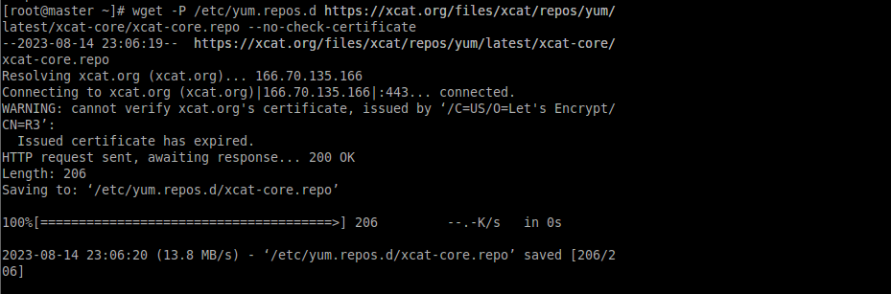

*# wget -P /etc/yum.repos.d https://xcat.org/files/xcat/repos/yum/xcat-dep/rh7/x86_64/xcat-dep.repo --no-check-certificate*

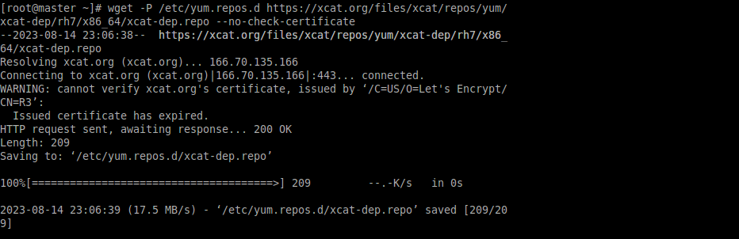

*# yum install xCAT*

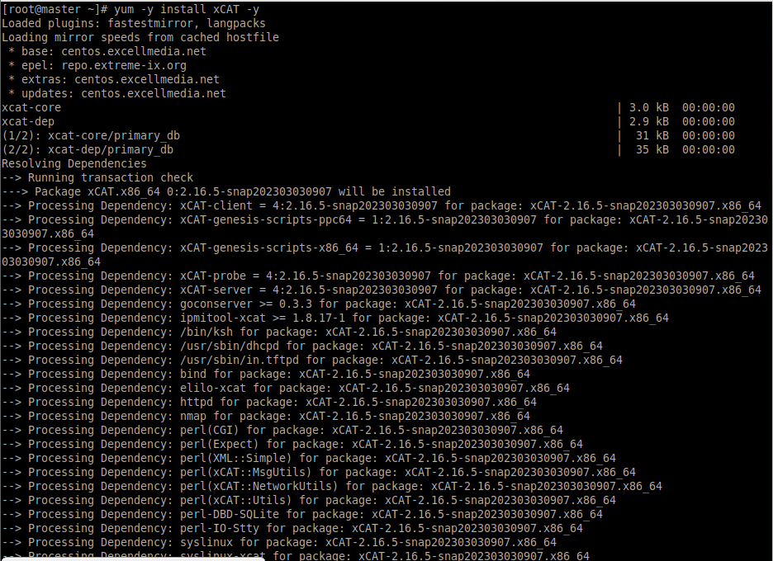

Now we will configure the XCAT on master for adding the compute nodes to the cluster

*# cat /etc/profile.d/xcat.sh 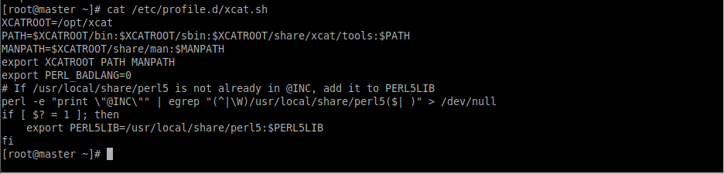*

*# source /etc/profile.d/xcat.sh*

*9.PNG*

*# tabdump sites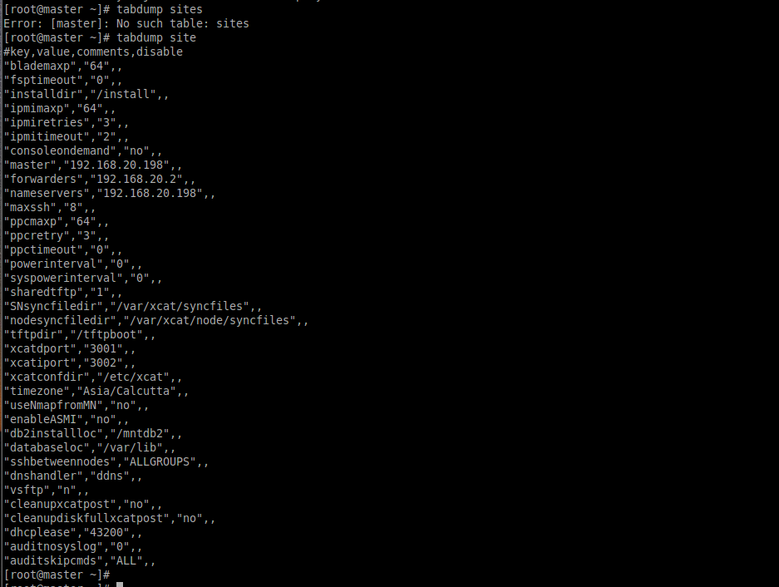*

*# lsblk*

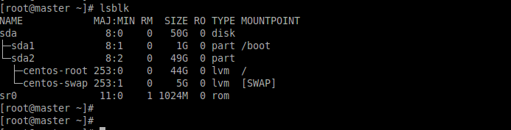

*# dd if=/dev/sr0 of=centos7.iso*

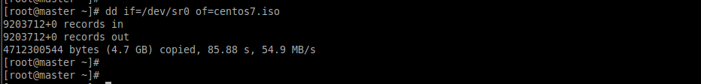

*# copycds centos.iso*

**

*# lsdef -t osimage*

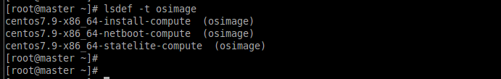

*# lsdef -t osimage centos7.9-x86_64-netboot-compute*

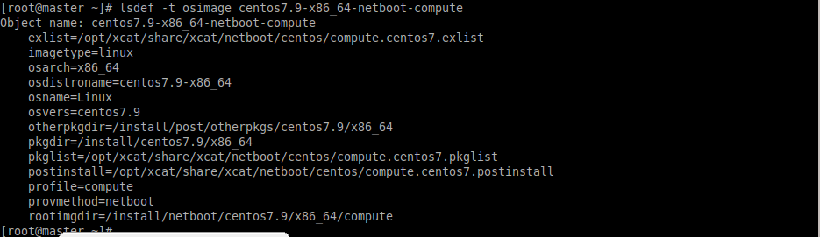

*# genimage centos7.9-x86_64-netboot-compute*

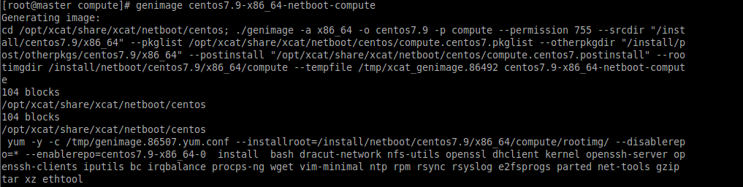

*# cd /install/netboot/centos7.9/x86_64/compute/*

*# mkdir -p /install/custom/netboot*

**

*# chdef -t osimage centos7.9-x86_64-netboot-compute synclists="/install/custom/netboot/compute.synclist"*

**

*# lsdef -t osimage centos7.9-x86_64-netboot-compute*

**

*# vim /install/custom/netboot/compute.synclist*

*# cat /install/custom/netboot/compute.synclist*

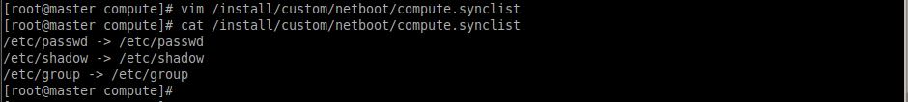

*# packimage centos7.9-x86_64-netboot-compute*

**

Now we will add the compute nodes in our cluster for that we will create one machine without specifying the OS image now the machine will assign the mac address note it down.

node1 :

mac address = 00:0C:29:4F:F8:0D

ip address = 192.168.20.200

node2 :

mac address = 00:0C:29:B0:79:A7

ip address = 192.168.20.201

*# mkdef -t node cn00 groups=compute,all ip=10.10.10.3 mac=00:0c:29:98:93:43 netboot=xnba*

*# lsdef cn00*

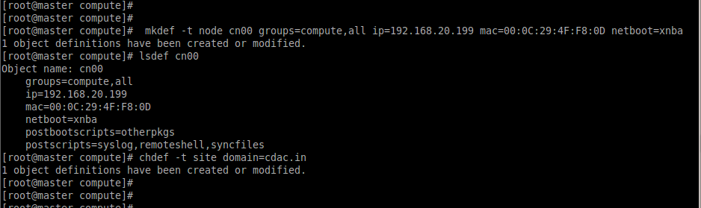

*# chdef -t site domain=cdac.in*

*22.PNG*

add below entry into the /etc/hosts file

92.168.20.198 master master.cdac.in ( master_ip master_hostname fqdn_for master)

*# makehosts*

*# cat /etc/hosts*

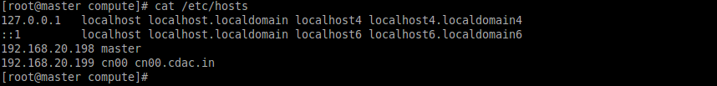

as we can notice the node1 entry is automatically adds to the /etc/hosts

*# makenetworks*

**

*# makedhcp -n*

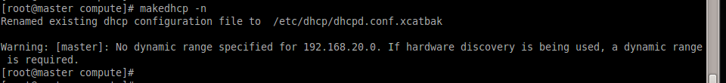

*# makedns –n*

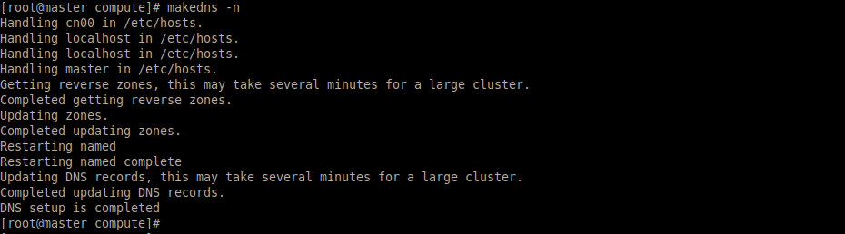

*# export CHROOT=/install/netboot/centos7.9/x86_64/compute/rootimg*

*29.PNG*

*# chroot $CHROOT*

**

*# ssh cn00*

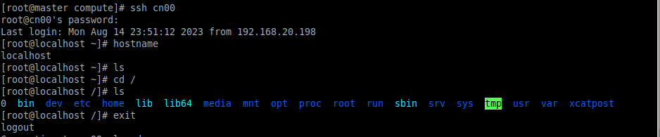

*# mkdef -t node cn01 groups=compute,all ip=10.10.10.4 mac=00:0C:29:A6:4A:D1 netboot=xnba*

*32.PNG*

*# lsdef cn01*

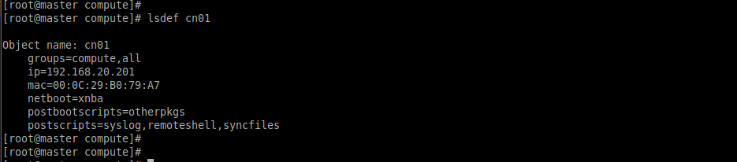

*#* *chdef -t site domain=cdac.in*

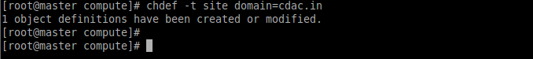

*#* *makedns -n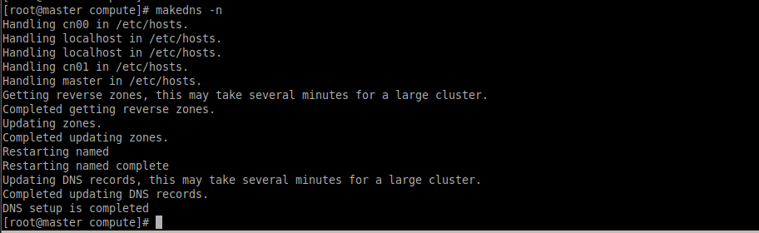*

*#* *nodeset compute osimage=centos7.9-x86_64-netboot-compute*

**

*#* *imgexport centos7.9-x86_64-netboot-compute*

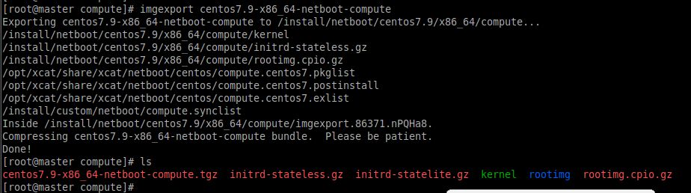

*# ssh cn01*

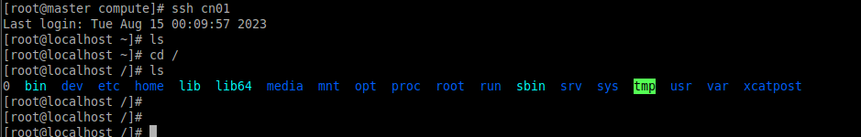

* **LDAP installation :**

Initially we will share the hosts file with the other nodes using the rsync

*# rsync /etc/hosts root@cn00:/etc/hosts*

*# rsync /etc/hosts root@cn01:/etc/hosts*

*# yum -y install openldap-servers openldap-clients*

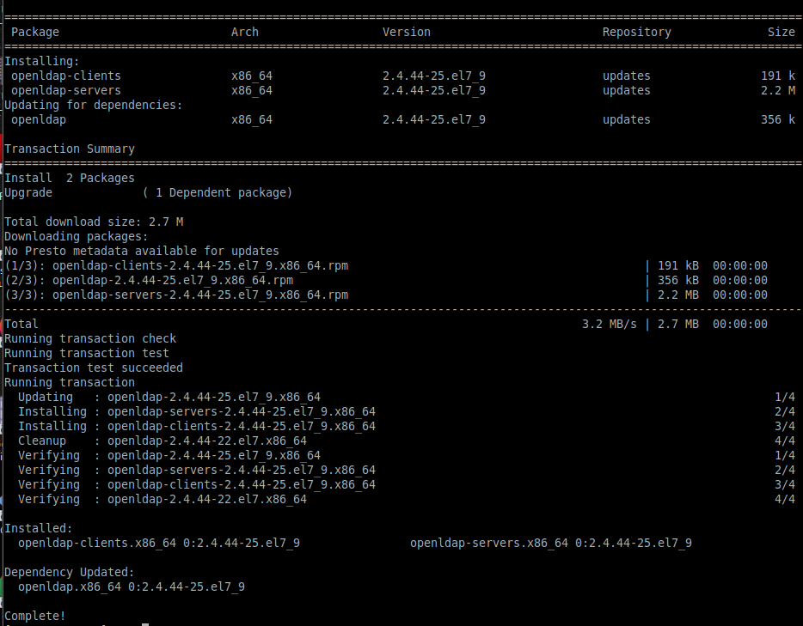

*# cp /usr/share/openldap-servers/DB_CONFIG.example /var/lib/ldap/DB_CONFIG*

*# chown ldap. /var/lib/ldap/DB_CONFIG*

*# systemctl start slapd*

*# systemctl enable slapd*

*# systemctl status slapd*

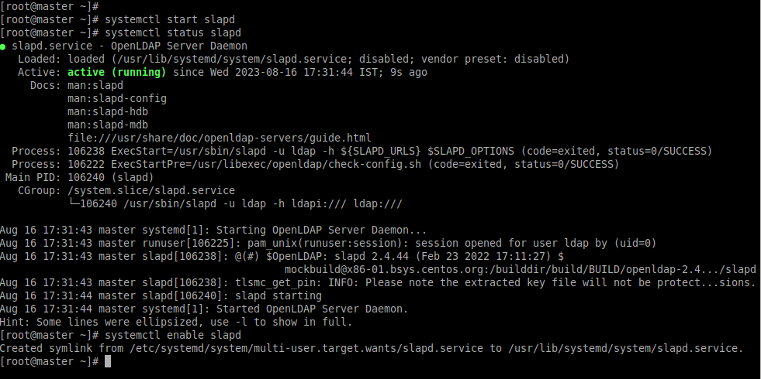

*# slappasswd*

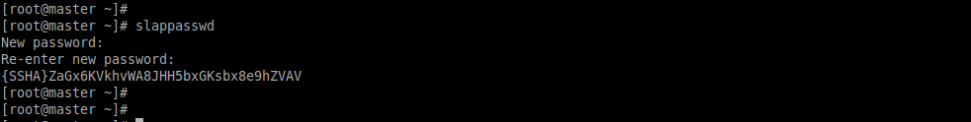

*# vi chrootpw.ldif*

add the following to the file

*dn: olcDatabase={0}config,cn=config*

*changetype: modify*

*add: olcRootPW*

*olcRootPW: {SSHA}P0OzwYC7JFOpwoHJPvoV0NR+rkvhuFXj*

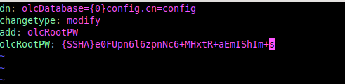

*# ldapadd -Y EXTERNAL -H ldapi:/// -f chrootpw.ldif*

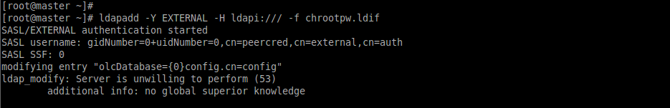

*# ldapadd -Y EXTERNAL -H ldapi:/// -f /etc/openldap/schema/cosine.ldif*

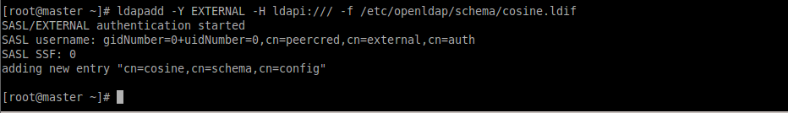

*# ldapadd -Y EXTERNAL -H ldapi:/// -f /etc/openldap/schema/nis.ldif*

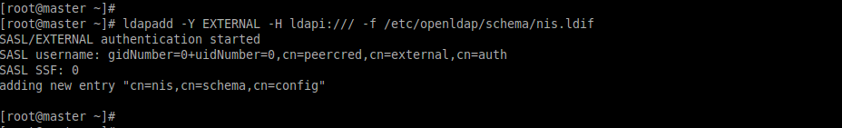

*# ldapadd -Y EXTERNAL -H ldapi:/// -f /etc/openldap/schema/inetorgperson.ldif*

**

*# vim chdomain.ldif*

add the following to the file

dn: olcDatabase={1}monitor,cn=config

changetype: modify

replace: olcAccess

olcAccess: {0}to * by dn.base="gidNumber=0+uidNumber=0,cn=peercred,cn=external,cn=auth"

read by dn.base="cn=Manager,dc=cdac,dc=in" read by * none

dn: olcDatabase={2}hdb,cn=config

changetype: modify

replace: olcSuffix

olcSuffix: dc=cdac,dc=in

dn: olcDatabase={2}hdb,cn=config

changetype: modify

replace: olcRootDN

olcRootDN: cn=Manager,dc=cdac,dc=in

dn: olcDatabase={2}hdb,cn=config

changetype: modify

add: olcRootPW

olcRootPW: {SSHA}P0OzwYC7JFOpwoHJPvoV0NR+rkvhuFXj

dn: olcDatabase={2}hdb,cn=config

changetype: modify

add: olcAccess

olcAccess: {0}to attrs=userPassword,shadowLastChange by

dn="cn=Manager,dc=cdac,dc=in" write by anonymous auth by self write by * none

olcAccess: {1}to dn.base="" by * read

olcAccess: {2}to * by dn="cn=Manager,dc=cdac,dc=in" write by * read

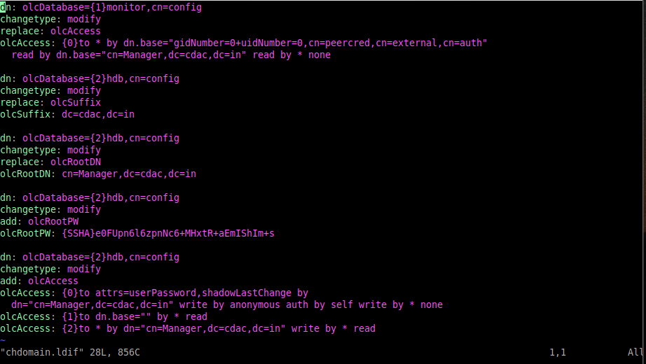

*# ldapmodify -Y EXTERNAL -H ldapi:/// -f chdomain.ldif*

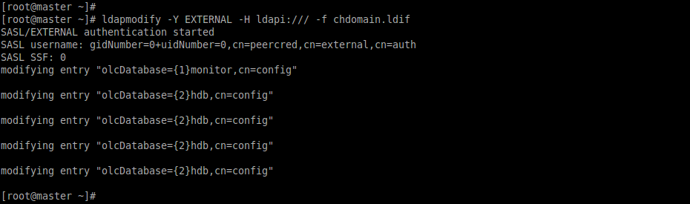

*# vi basedomain.ldif*

add the following to the file

*dn: dc=cdac,dc=in*

*objectClass: top*

*objectClass: dcObject*

*objectclass: organization*

*o: cdac in*

*dc: cdac*

*dn: cn=Manager,dc=cdac,dc=in*

*objectClass: organizationalRole*

*cn: Manager*

*description: Directory Manager*

*dn: ou=People,dc=cdac,dc=in*

*objectClass: organizationalUnit*

*ou: People*

*dn: ou=Group,dc=cdac,dc=in*

*objectClass: organizationalUnit*

*ou: Group*

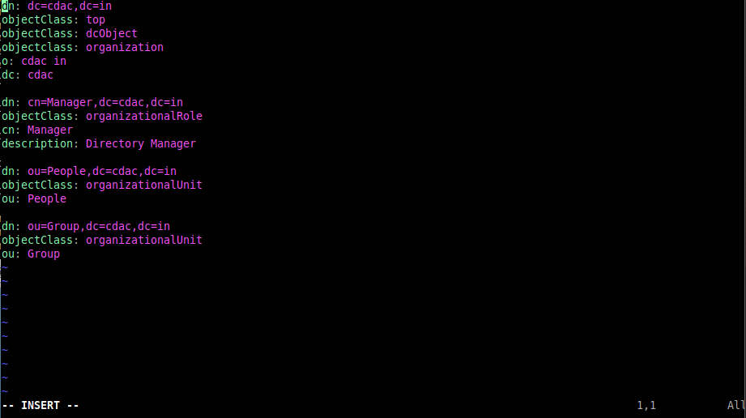

*# ldapadd -x -D cn=Manager,dc=cdac,dc=in -W -f basedomain.ldif*

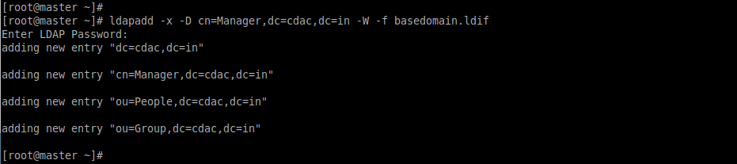

*# vi ldapuser.ldif*

add the following to the file

dn: uid=hpcsa,ou=People,dc=cdac,dc=in

objectClass: inetOrgPerson

objectClass: posixAccount

objectClass: shadowAccount

cn: hpcsa

sn: Linux

userPassword: {SSHA}P0OzwYC7JFOpwoHJPvoV0NR+rkvhuFXj

loginShell: /bin/bash

uidNumber: 1100

gidNumber: 1100

homeDirectory: /home/hpcsa

dn: cn=hpcsa,ou=Group,dc=cdac,dc=in

objectClass: posixGroup

cn: hpcsa

gidNumber: 1100

memberUid: hpcsa

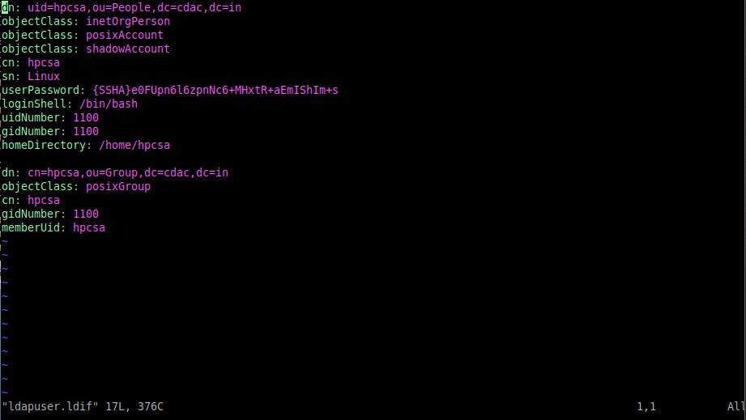

*# ldapadd -x -D cn=Manager,dc=cdac,dc=in -W -f ldapuser.ldif*

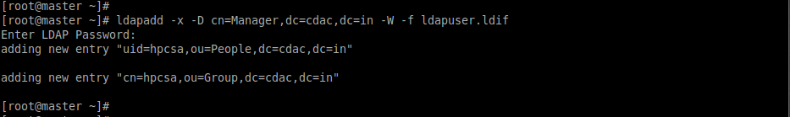

* **Node side configuration :**

*# yum -y install openldap-clients nss-pam-ldapd*

*# authconfig --enableldap --enableldapauth --ldapserver=master --ldapbasedn="dc=cdac,dc=in" --enablemkhomedir –update*

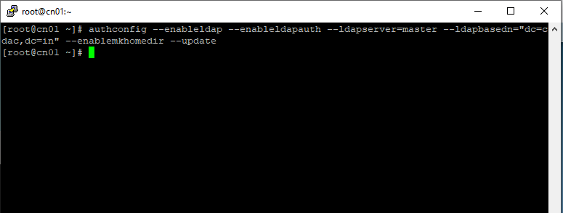

*# systemctl restart nslcd*

*# ldapsearch -x*

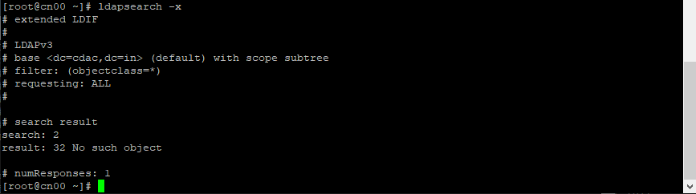

*# cat /etc/nslcd.conf*

*# cat /etc/nsswitch.conf*

*# getent passwd*

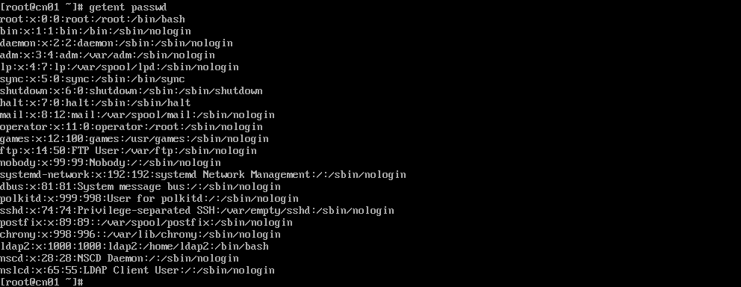

*# ssh hpcsa@client*

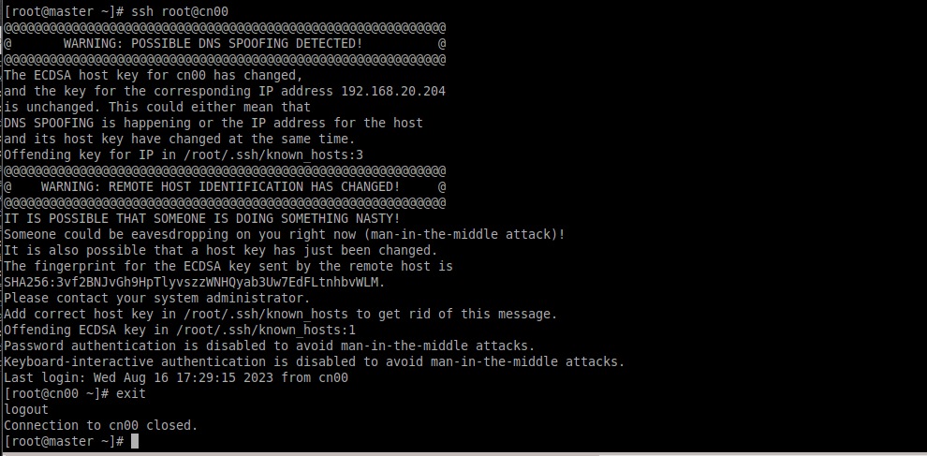

* **SLURM Configuration for cluster**
* **Master side configuration :**

Here first we will configure and check for disabled firewall, disabled SELINUX and the entries to the file /etc/hosts

once this done

*# yum install epel-release.noarch*

*# yum install nfs-utils.x86_64 –y*

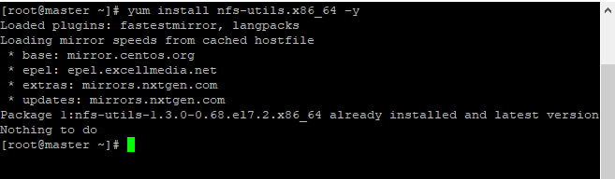

*#systemctl start nfs-server.service*

*#systemctl enable nfs-server.service*

*# useradd admin*

*# passwd admin*

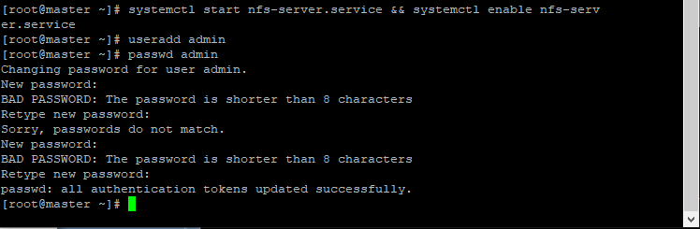

* **Master side configuration**

*# chmod 777 /home/*

*# vi /etc/exports*

add following into the file

/home/ 10.10.10.136(rw,sync,no_root_squash)

/home/ 10.10.10.137(rw,sync,no_root_squash*)*

*# exportfs -avr*

*# ssh-keygen*

*# ssh-copy-id root@node1*

*# ssh-copy-id root@node2*

*# su - admin*

3.PNG

*# ssh-keygen*

*# ssh-copy-id admin@node1*

*# ssh-copy-id admin@node2*

* **For all machines**

*# yum install munge munge-libs munge-devel –y*

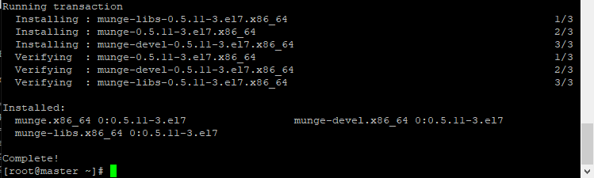

* **Master side configuration**

*# /usr/sbin/create-munge-key –r*

*# scp /etc/munge/munge.key node1:/etc/munge/*

*# scp /etc/munge/munge.key node2:/etc/munge/*

*# systemctl start munge.service*

*# systemctl enable munge.service*

* **Node side configuration**

*# chown munge:munge /etc/munge/munge.key*

*# systemctl start munge.service && systemctl enable munge.service*

*# mount -t nfs 10.10.10.135:/home/ /home/*

* **Master side configuration**

*# wget* [*https://download.schedmd.com/slurm/slurm-20.11.9.tar.bz2*](https://download.schedmd.com/slurm/slurm-20.11.9.tar.bz2)

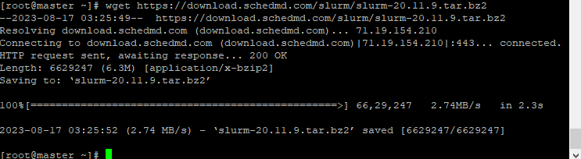

*# yum install rpm-build*

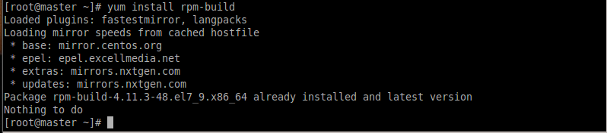

*# rpmbuild -ta slurm-20.11.9.tar.bz2*

If get failed install required dependences

*# yum install python3 readline-devel perl-ExtUtils-MakeMaker pam-devel -y*

*# rpmbuild -ta slurm-20.11.9.tar.bz2*

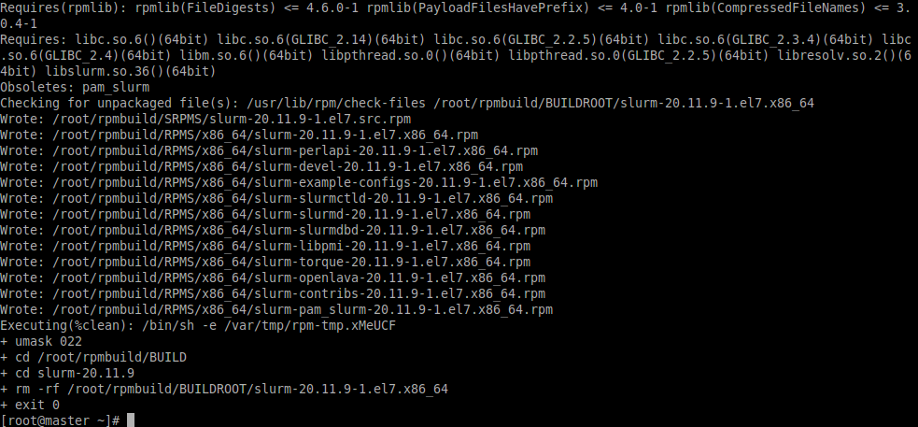

* **Node side configuration**

*# yum install pam-devel python3 redline-devel perl-ExtUtils-MakeMaker mysql-devel -y*

* **For all machines**

*# export SLURMUSER=900*

*# groupadd -g $SLURMUSER slurm*

*# useradd -m -c "SLURM workload manager" -d /var/lib/slurm -u $SLURMUSER -g slurm -s /bin/bash slurm*

* **Master side configuration**

*# ll /root/rpmbuild/RPMS/x86_64/*

*# mkdir /home/rpms*

*# cd /root/rpmbuild/RPMS/x86_64/*

*# cp * /home/rpms/*

* **For all machines**

*# cd /home/rpms/*

*# yum install localinstall * -y*

* **Node side configuration**

*# rpm -e slurm-slurmctld-20.11.9-1.el7.x86_64*

*# rpm -e slurm-slurmdbd-20.11.9-1.el7.x86_64*

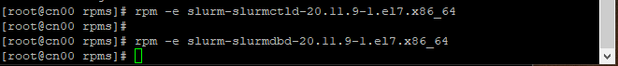

We deleted these packages from node machines because we don’t need it

* **For all machines**

*# mkdir /var/spool/slurm*

*# chown slurm:slurm /var/spool/slurm*

*# chmod 755 /var/spool/slurm/*

*# mkdir /var/log/slurm/*

*# chown -R slurm . /var/log/slurm*

* **Master side configuration**

*# touch /var/log/slurm/slurmctld.log*

*# chown slurm:slurm /var/log/slurm/slurmctld.log*

*# touch /var/log/slurm_jobaact.log*

*# touch /var/log/slurm_jobcomp.log*

*# chown slurm: /var/log/slurm_jobaact.log*

*# chown slurm: /var/log/slurm_jobcomp.log*

*# cp /etc/slurm/slurm.conf.example /etc/slurm/slurm.conf*

*# vi /etc/slurm/slurm.conf*

update the following

On line 11. clustername=hpcsa

On line 12. ControlMachine=master

Comment line no. 92

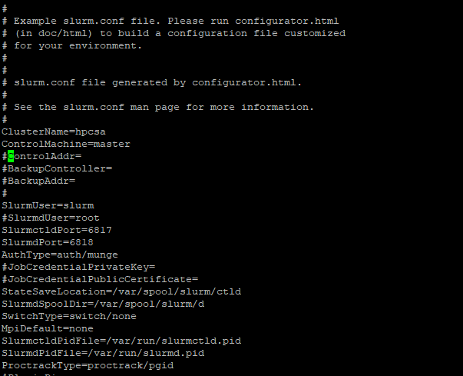

* **Node side configuration**

*# systemctl start slurmd.service && systemctl enable slurmd.service*

*# slurmd -C*

* **Master side configuration**

*#vi /etc/slurm/slurm.conf*

update the following

line no 93. PartitionName=standard Nodes=ALL Default=YES MaxTime=INFINITE State=UP

line no 94. NodeName=node1 CPUs=4 Boards=1 SocketsPerBoard=4 CoresPerSocket=1 Thread sPerCore=1 RealMemory=3770 state=UNKNOWN (slurmd -C outputline of node1)

line no 95. NodeName=node2 CPUs=4 Boards=1 SocketsPerBoard=4 CoresPerSocket=1 Thread sPerCore=1 RealMemory=3770 State=UNKNOWN (slurmd -C outputline of node1)

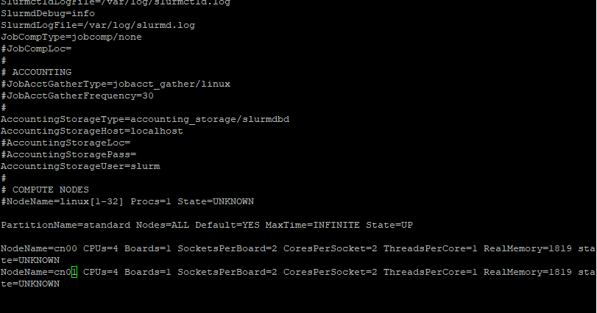

*# scp /etc/slurm/slurm.conf node1:/etc/slurm/*

*# scp /etc/slurm/slurm.conf node2:/etc/slurm/*

*# systemctl start slurmctld.service && systemctl enable slurmctld.service*

*# sinfo*

* **NAGIOS Configuration for cluster**
* **Master side configuration**

*# yum install* [*http://build.openhpc.community/OpenHPC:/1.3/CentOS_7/x86_64/ohpc-release-1.3-1.el7.x86_64.rpm*](http://build.openhpc.community/OpenHPC:/1.3/CentOS_7/x86_64/ohpc-release-1.3-1.el7.x86_64.rpm)

*#yum -y install ohpc-nagios*

*#cd /etc/nagios/*

*#htpasswd -bc /etc/nagios/passwd nagiosadmin nagiosadmin*

6.PNG

*#mkdir /var/run/nagios/*

*#chown –R nagios:nagios /var/run/nagios/*

*#systemctl start nagios*

*#systemctl status nagios*

*#systemctl start httpd*

*#systemctl status httpd*

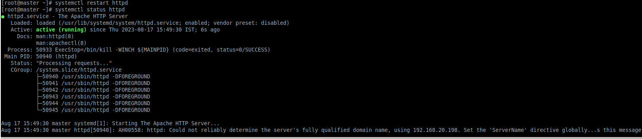

*# vim /etc/nagios/nrpe.cfg*

update following to the file

allowed_host =192.168.20.198 ----(master ip address)

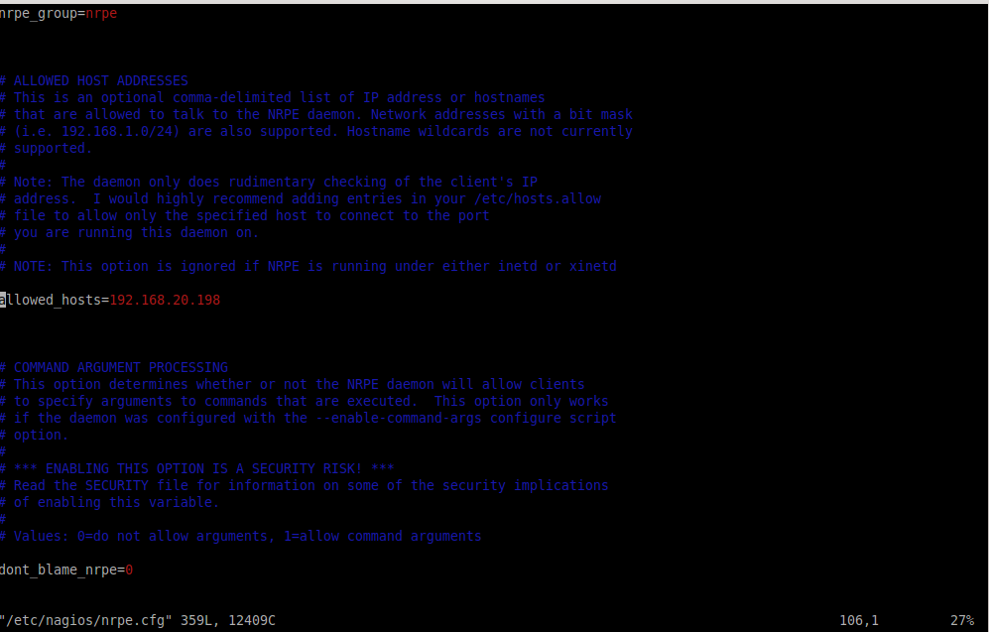

*#systemctl start nrpe*

*#systemctl status nrpe*

*#chown -R nrpe:nrpe /var/log/nagios/*

*#systemctl restsrt nrpe*

*#cd /etc/nagios/conf.d/*

*#cp hosts.cfg.example hosts.cfg*

*#vim hosts.cfg*

update the following

define hostgroup(

.

.

members cn00,cn01

}

define host{

- - - -

host_name cn00

alias cn00

address 192.168.20.204

}

define host{

- - - -

host_name cn01

alias cn01

address 192.168.20.205

}

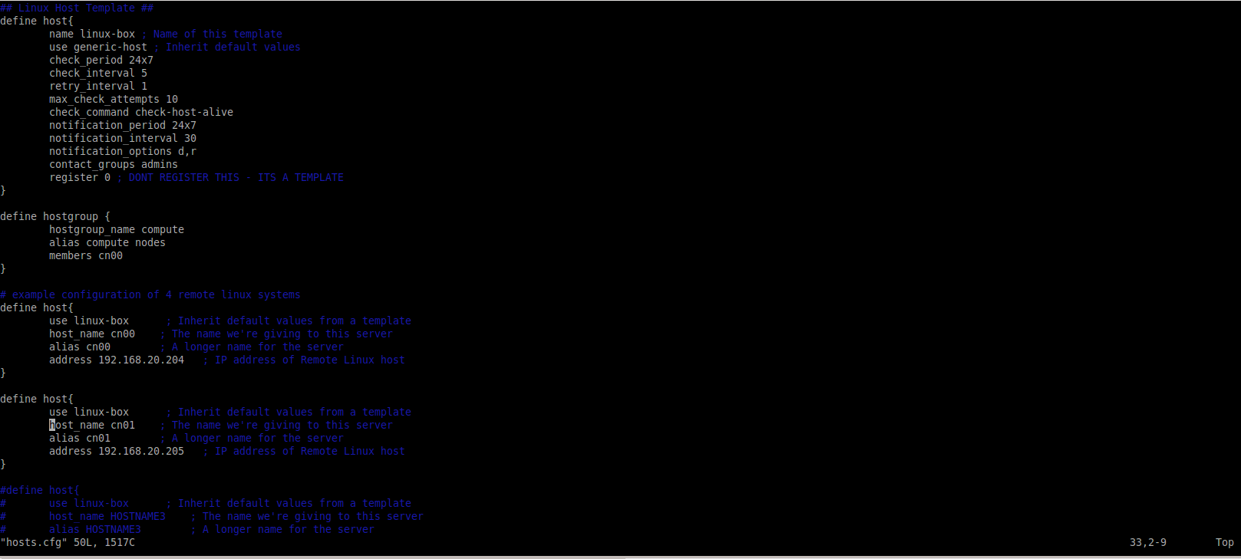

*#systemctl restart nagios*

*#chown -R nagios:nagios /etc/nagios/conf.d/hosts.cfg*

*#systemctl restart nagios*

*#cd /etc/nagios/conf.d/*

*# cp services.cfg.example services.cfg*

*# systemctl restart nagios*

*#systemctl status nagios*

*#systemctl status httpd*

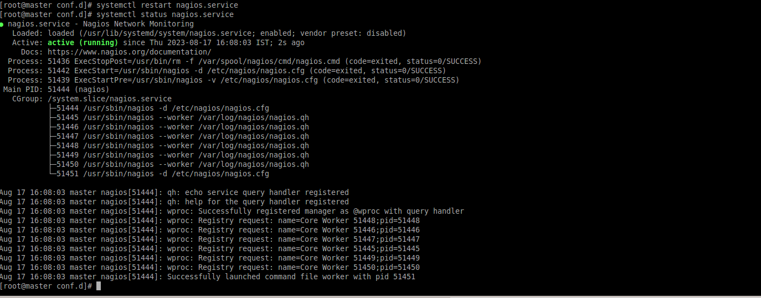

Take Machine Ip and put in Web browser

http://192.168.20.161/nagios/

